TALLAHASSEE SERINA’S
POINSETTIA SALE
Beautiful FLORIST QUALITY Plants
Foiled Covered 6” pots
16-18 inches tall
5-7 blooms per plant
Color Choice: Red, Pink, or White
Shipped with protective sleeve

$10 per Poinsettia

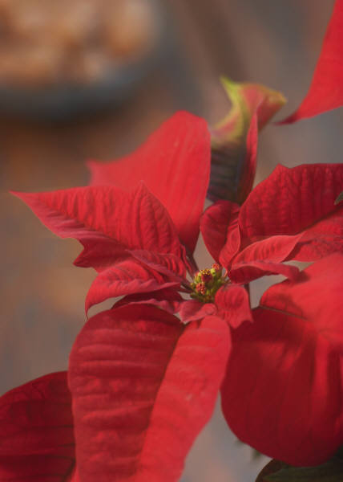

ORDERS AND MONEY DUE NOVEMBER 9TH

Poinsettias will arrive the first week of December!

