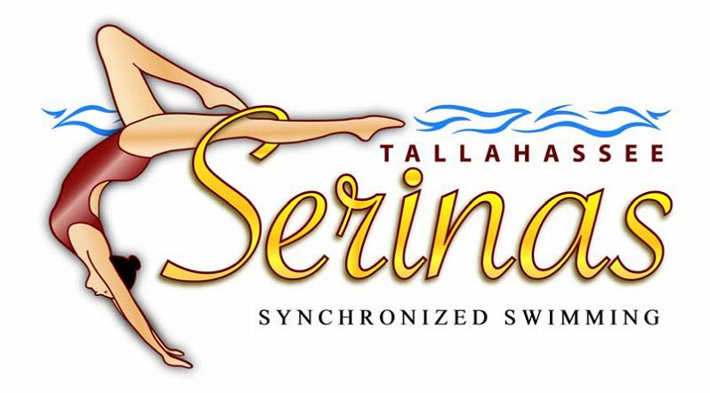

Coffee Fundraiser Benefiting
Your Tallahassee Serina!

Each delicious Lucky Goat Coffee blend (whole bean or ground) is being sold for $10 and YOUR swimmer will earn 40% from every 12 oz. bag purchased. This 40% will be placed in your swimmer’s travel account to help pay for out of town meet costs and entry fees.
To insure a timely delivery, please make sure that all orders are turned in by the corresponding deadline to Kristin Badeau. Please make checks payable to Tallahassee Serinas.

ORDER FORM INSTRUCTIONS
- Completely fill out order form.
- Sell coffee to local family, friends, and neighbors. Be sure to use the “wb” column for whole bean coffee and the “gr” column for ground coffee.
- Collect money at the time of sale (make checks payable to Tallahassee Serinas).
- Tally the total bags of each coffee sold and the total amount of money due.
- Turn in the money and order form to Kristin Badeau (Lauren B’s mom) by Friday, December 4th. If you do not swim on Friday, turn in your order form and money on Thursday, December 3rd.
NO LATE SUBMISSIONS WILL BE ACCEPTED.
For more information, please contact Kristin Badeau kristinbadeau@gmail.com (408-3581).

Coffee will be delivered to the pool by Wednesday, December 16, 2015.

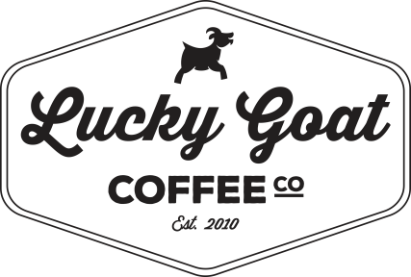

Decaf: For those looking for a great tasting coffee without the caffeine! We offer our smooth bodied Breakfast Blend in decaffeinated form. Low acidity and full flavor without the jitters.

Breakfast Blend( Billy Goat): Our best Central and South American coffees blended together to create a smooth, light bodied blend with a low acidity. Our breakfast blend has a natural sweetness that's perfect as an early morning push, but excellent anytime day or night.

Roastmaster’s Blend: Four of our fist coffees blended and roasted to perfection to create a complex, yet delicate balance of smooth body and citrus acidity with an aftertaste that will leave you wanting more. We let our roastmaster develop a special blend that will put you on the cutting edge of great coffees and will make your taste buds dance. This is a must have if you love fine coffee.

French Roast: The darkest roast we offer. This midnight blend is great for a jolt to the taste buds and your senses. The smokey flavor of a French Roast combines with a heavy body blend that shines through from first sip to the last drop, leaving a long lasting aftertaste.

Cinnamon Crunch: Cinnamon and Hazelnut combine to transport you to a day of comfort and relaxation. Get ready to leisurely start your day.

Snowflake Crunch: Cinnamon, Hazelnut and Vanilla dance together in our top selling flavored coffee every year. With the hint of winter in the air this will start your Holliday Season off right!

Moose Tracks: The rich and creamy combination of Chocolate and Caramel that can only be described as decadent. This classic duo will melt in your mouth and warm your heart. Try this premium coffee with a little cream and sugar; you might kick your favorite ice cream flavor to the curb.

Southern Pecan: Only the deep history of the beautiful southern plantations can provide this perfect pair...smooth coffee and pecan flavor. We won't tell your grandma!

ALL 12oz. bags (whole bean or ground) - $10 each

